Daily Assignment on FETCH API
Approach:
The application was developed using HTML, CSS (Bootstrap), and JavaScript.
The Fetch API was used to retrieve blog posts and todo items from the JSONPlaceholder public APIs. To improve code organization and scalability, the Module Pattern (Revealing Module Pattern) was implemented.
Snapshot of the webpage :
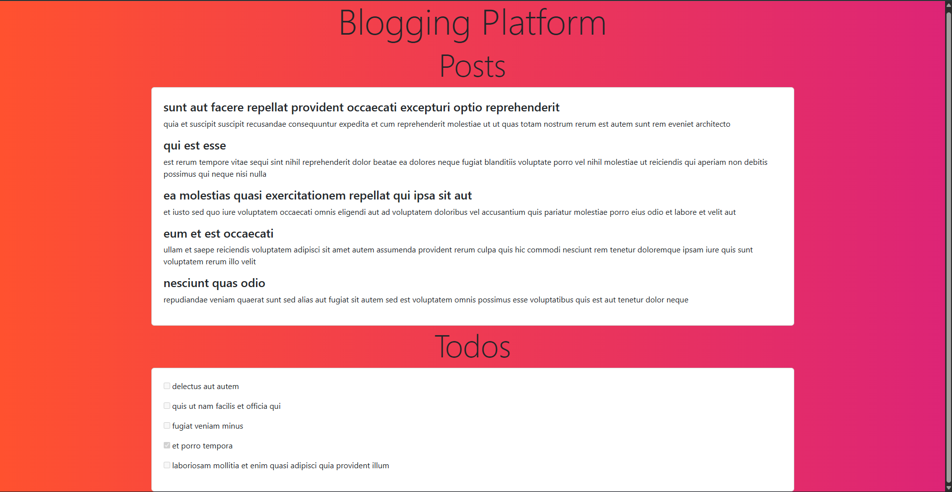

Html Code:
Written using Bootstrapa and some inline-css:
<!doctype html>
<html lang="en">
<head>
<meta charset="UTF-8" />
<title>Blog Website</title>
<link
href="https://cdn.jsdelivr.net/npm/bootstrap@5.3.8/dist/css/bootstrap.min.css"
rel="stylesheet"
integrity="sha384-sRIl4kxILFvY47J16cr9ZwB07vP4J8+LH7qKQnuqkuIAvNWLzeN8tE5YBujZqJLB"
crossorigin="anonymous"
/>
</head>
<body style="height: 100vh; background-image: linear-gradient(to right, #ff512f, #dd2476);">
<h1 class="display-2 text-center">Blogging Platform</h1>

<h2 class="display-3 text-center">Posts</h2>
<div class="container d-flex justify-content-center">
<div class="card col-md-12 p-4" id="posts"></div>
</div>

<h2 class="display-3 text-center">Todos</h2>
<div class="container d-flex justify-content-center mb-5">
<div class="card col-md-12 p-4" id="todos"></div>
</div>

<script src="script.js"></script>
</body>
</html>

Script.js:
// App Module using Revealing Module Pattern
const App = (function () {

// API endpoints
const POSTS = "https://jsonplaceholder.typicode.com/posts";
const TODOS = "https://jsonplaceholder.typicode.com/todos";

// DOM elements where data will be displayed
const postsContainer = document.getElementById("posts");
const todosContainer = document.getElementById("todos");

// Common function to fetch data from an API
async function fetchData(url) {
try {
// Make API request
const response = await fetch(url);

// Check for HTTP errors
if (!response.ok) {
throw new Error("Server responded with error");
}

// Convert response to JSON
return await response.json();
} catch (error) {
// Propagate error to calling function
throw error;
}
}

// Fetch and display blog posts
async function loadPosts() {
try {
// Fetch posts data
const posts = await fetchData(POSTS);

// Display first 5 posts
posts.slice(0, 5).forEach(post => {
const div = document.createElement("div");
div.className = "post";

// Insert post title and body
div.innerHTML = `
<h4>${post.title}</h4>
<p>${post.body}</p>
`;

postsContainer.appendChild(div);
});
} catch (error) {
// Display error message if posts fail to load
postsContainer.innerHTML = `<p class="error">Failed to load posts</p>`;
}
}

// Fetch and display todo items
async function loadTodos() {
try {
// Fetch todos data
const todos = await fetchData(TODOS);

// Display first 5 todos
todos.slice(0, 5).forEach(todo => {
const div = document.createElement("div");
div.className = "todo";

// Insert todo title with checkbox
div.innerHTML = `
<p>
<input type="checkbox" ${todo.completed ? "checked" : ""} disabled />
${todo.title}
</p>
`;

todosContainer.appendChild(div);
});
} catch (error) {
// Display error message if todos fail to load
todosContainer.innerHTML = `<p class="error">Failed to load todos</p>`;
}
}

// Expose only the init method
return {
init: function () {
loadPosts();
loadTodos();
}
};

})(); // Immediately Invoked Function Expression

// Initialize the application
App.init();
Through this assignment, I gained practical experience in using the Fetch API to handle asynchronous operations and work with JSON data. I learned how to implement proper error handling and dynamically update the DOM. The use of the Module Pattern helped me understand how JavaScript design patterns improve code organization and scalability. Debugging real-time issues improved my problem-solving and debugging skills.

